FinTrack Prime
Backend Technical Documentation
Capstone Project — Backend API
Prepared for panel review
Generated from the FinTrackPrime.Backend source code

1. Introduction
This document describes the backend API for FinTrack Prime, a personal finance management system built as a capstone project. It covers the technology stack, the architecture, how users are authenticated and authorized, how premium purchases are verified with PayPal, the database schema, and the full list of API endpoints. Every detail in this document reflects the actual source code — it is not a design proposal.
2. Technology Stack
Layer / Concern | Technology
Language | C#
Runtime / Framework | .NET 10 — all three projects target net10.0
Web framework | ASP.NET Core Web API
ORM | Entity Framework Core 10.0.10
Database | Microsoft SQL Server (via the EF Core SQL Server provider)
API documentation | Swagger / OpenAPI, generated by Swashbuckle.AspNetCore
Authentication | JWT Bearer tokens + Google Sign-In (ID token verification)
Payment gateway | PayPal REST API (Sandbox environment)

3. Architecture
The backend is split into three projects, layered so that each one depends only on the one below it. Controllers in the top layer depend on interfaces, never on concrete service classes, which is the core idea borrowed from Clean Architecture — implementations can change without the presentation layer knowing.
Project | Responsibility | Depends on
FinTrackPrime.WebApi | Controllers, Program.cs startup/DI wiring, JWT validation, CORS, Swagger. | FinTrackPrime.Business (via interfaces)
FinTrackPrime.Business | Interfaces and their service implementations: all business rules, password hashing, JWT issuance, PayPal verification. | FinTrackPrime.Models
FinTrackPrime.Models | Entities, view models (DTOs), FinTrackDbContext, EF Core migrations. The only project that references SQL Server directly. | SQL Server (via EF Core)

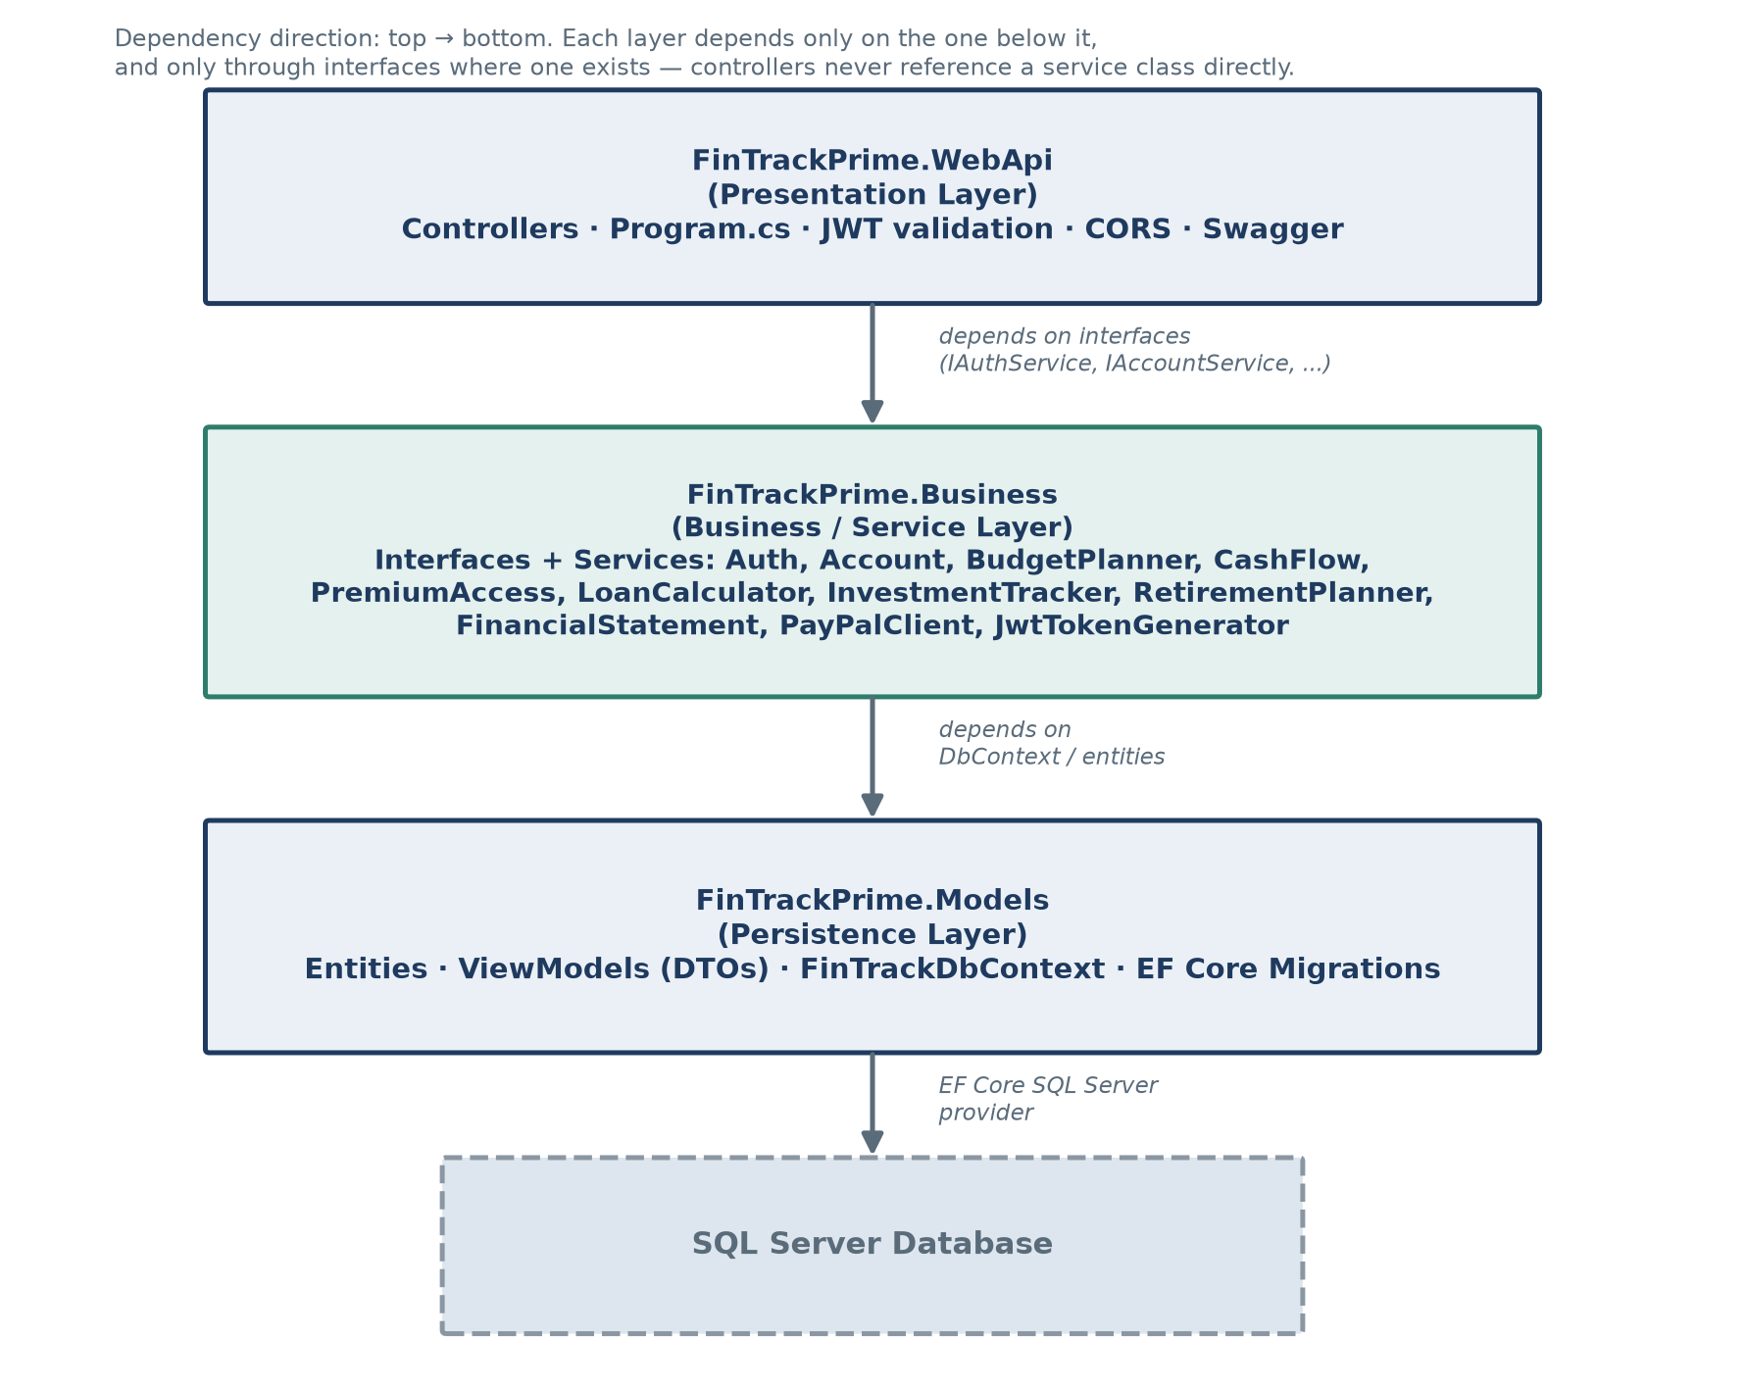
Figure 1 — Layered project architecture and dependency direction.
Cross-cutting concerns configured in Program.cs
- Dependency injection: every service interface is registered as Scoped, so each HTTP request gets its own instance sharing one DbContext.
- PayPal client: registered as a typed HttpClient (AddHttpClient<IPayPalClient, PayPalClient>) with its BaseAddress read from configuration, so switching PayPal sandbox → live is a config change, not a code change.
- JSON serialization: enums (PremiumTool, BudgetCategoryType, TransactionDirection, AccountType) serialize as their string names (e.g. "LoanCalculator"), not as numbers, via JsonStringEnumConverter.
- CORS: a named policy ("FrontendPolicy") allows the configured frontend origin(s), any header, any method, and credentials — AllowCredentials is required for the browser to send the HttpOnly refresh-token cookie cross-origin.
4. Authentication & Authorization
Password authentication
Passwords are never stored in plain text. Each user gets a unique random 16-byte salt; the password is hashed with PBKDF2 (HMAC-SHA256, 100,000 iterations) into a 32-byte hash. Both the hash and the salt are stored Base64-encoded on the User record. Verifying a login re-derives the hash from the submitted password and the stored salt, then compares it to the stored hash using a fixed-time comparison (CryptographicOperations.FixedTimeEquals) so the comparison itself can't leak timing information. Login and register return the same generic "Invalid email or password" message whether the account doesn't exist, has no password set (Google-only account), or the password is wrong — this stops the endpoint from being used to discover which accounts exist.
Google Sign-In
The frontend — not this backend — talks to Google directly, using Google Identity Services to obtain a signed Google ID token. That token is POSTed to /api/auth/google, and the backend validates it itself (GoogleJsonWebSignature.ValidateAsync) against the configured Google Client ID. Matching an existing user happens by GoogleId first; if no match and Google reports the email as verified, it falls back to matching by email and links the Google identity to that existing password account. Otherwise a new Google-only account is created (no password hash/salt).
JWT access tokens
Access tokens are signed with HMAC-SHA256 using a symmetric key from configuration. Default lifetime is 15 minutes (Jwt:AccessTokenMinutes). Claims carried in every token:
Claim | Value | Purpose
sub | User.Id (GUID) | Identifies the calling user; every controller reads this to scope data access to its owner.
email | User.Email | Included for convenience/display.
fullName | User.FullName | Included for convenience/display.
unlock:{Tool} | "True" — one claim per unlocked tool | Backs the four per-tool authorization policies. A tool the user hasn't bought simply has no claim at all.

Refresh tokens & session rotation
A refresh token is a random 32-byte value, Base64URL-encoded, delivered only inside an HttpOnly cookie named ftp_refresh, scoped to path /api/auth (it is never present in any JSON response body). Only its SHA-256 hash is stored server-side. Default lifetime is 30 days (RefreshToken:ExpiryDays). Cookie flags adapt to the environment: Secure=false/SameSite=Lax in development (plain http://localhost), Secure=true/SameSite=None everywhere else (required for a deployed frontend on a different domain).
Rotation with reuse detection: every call to /api/auth/refresh revokes the presented token and issues a new one sharing the same FamilyId (one family = one login session). If a token that was already revoked is presented again — the signature of a stolen cookie being replayed after the real client has moved on — the entire family is revoked at once, forcing every session descended from that login to re-authenticate.
Per-tool authorization policies
Premium access is not a single all-or-nothing flag. Each of the four premium tools is gated by its own claim-based authorization policy, registered in Program.cs and enforced with [Authorize(Policy = "...")] on that tool's controller:
Policy name | Required claim | Applied to controller
RequireLoanCalculator | unlock:LoanCalculator = True | LoanCalculatorController
RequireInvestmentTracker | unlock:InvestmentTracker = True | InvestmentTrackerController
RequireRetirementPlanner | unlock:RetirementPlanner = True | RetirementPlannerController
RequireFinancialStatement | unlock:FinancialStatement = True | FinancialStatementController

Because each policy checks a different claim, owning one tool grants no access to the other three — a user who buys only the Loan Calculator gets a 403 Forbidden from the other three controllers until they buy those separately.
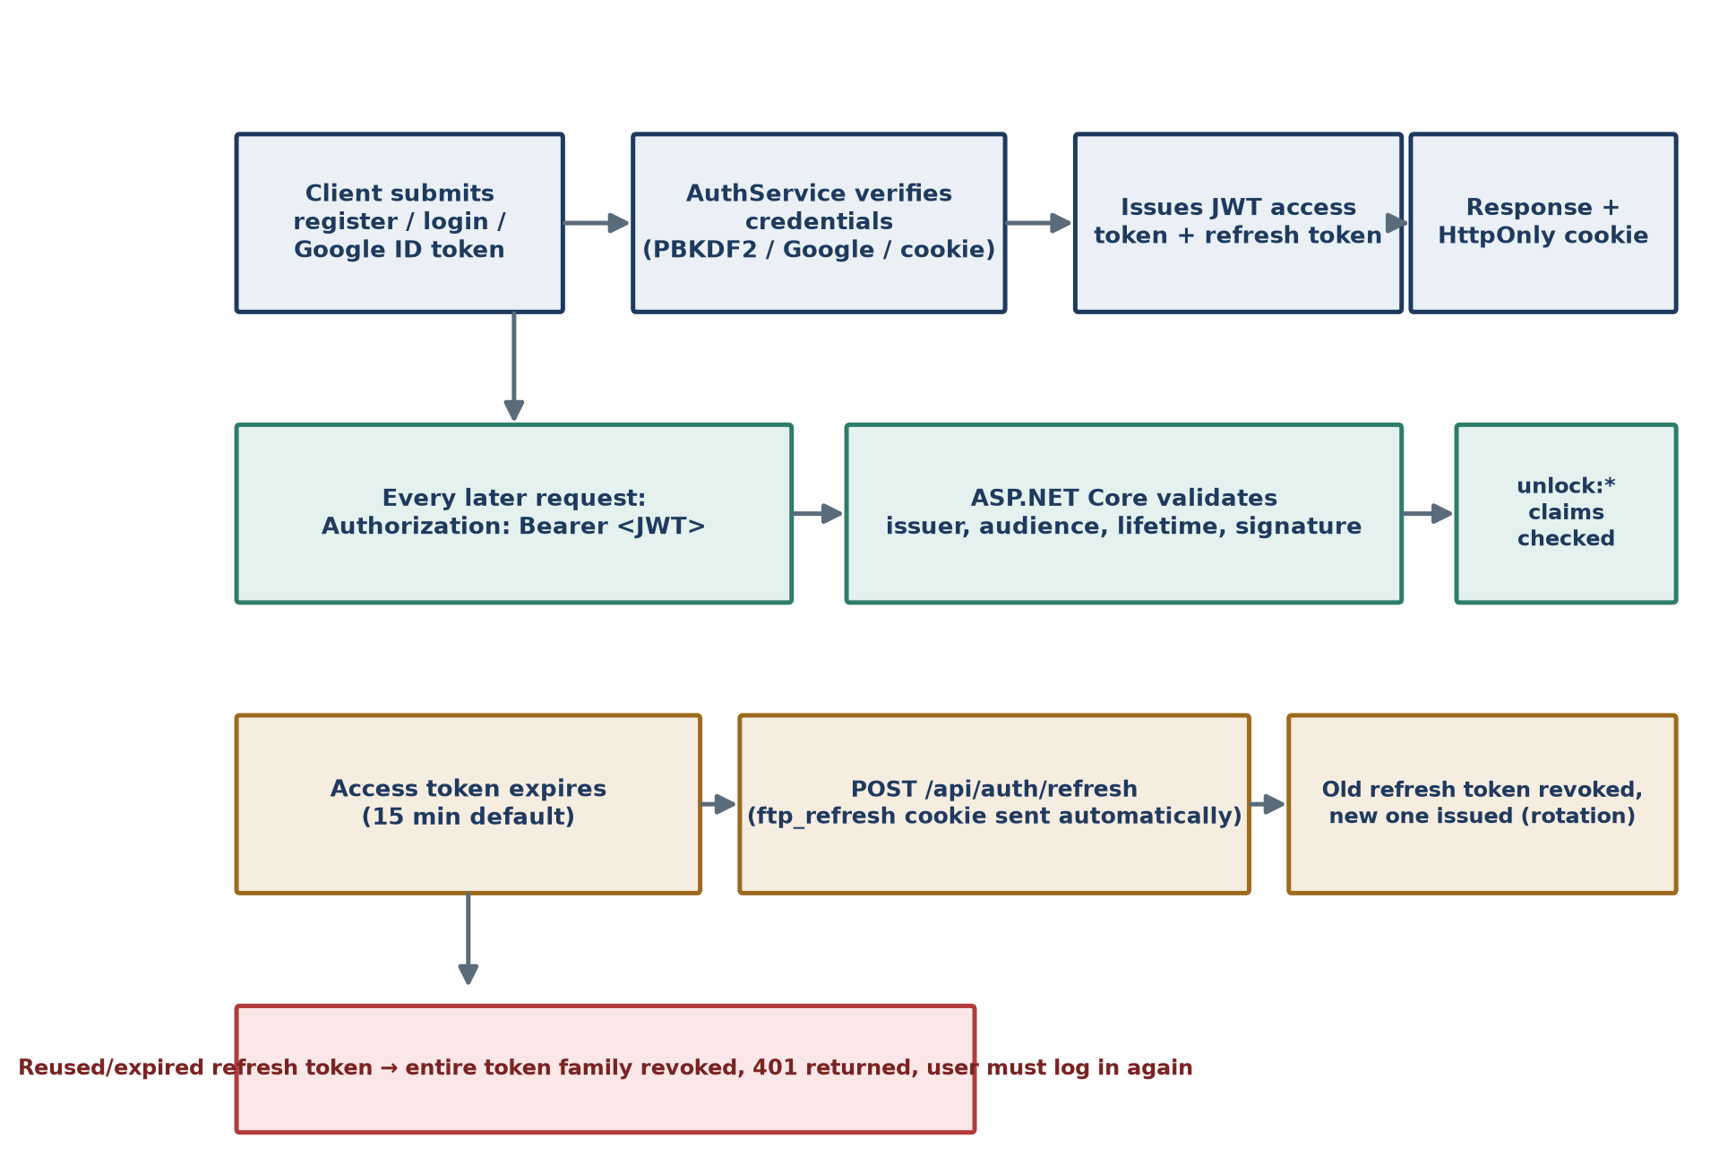
Figure 2 — Authentication, bearer validation, and refresh-token rotation.
5. Payment Integration — PayPal
Each of the four premium tools is purchased independently through PayPal. The frontend's PayPal button handles the buyer-facing approval flow, but nothing it reports is trusted on its own — the backend independently re-verifies the order directly with PayPal's REST API before granting any access.
Server-to-server authentication: OAuth2 client credentials
Before checking an order, the backend obtains its own PayPal access token via the OAuth2 client-credentials grant: a POST to /v1/oauth2/token with HTTP Basic auth built from PayPal:ClientId and PayPal:ClientSecret, and grant_type=client_credentials in the body. This is server-to-server only — the buyer's browser is never involved in this call, and the frontend never sees the client secret.
Order verification and business rules
On POST /api/checkout/verify, the backend applies these checks in order before granting anything:
- Reject immediately if the given PayPalOrderId has already been used by anyone (enforced by a unique database index on PremiumPurchases.PayPalOrderId) — checked before calling PayPal at all.
- Reject if the calling user already owns this specific tool.
- Call PayPal's GET /v2/checkout/orders/{id} (with the access token above) to fetch the order's real status, amount, and currency.
- Reject if the order status is not COMPLETED.
- Reject if the currency doesn't match Premium:Currency, or the amount is less than Premium:PriceUsd.
- Only then: insert a PremiumPurchase row and issue a brand-new JWT that includes the unlock:{Tool} claim for the tool just purchased. The old JWT keeps working until it expires but has no knowledge of the new purchase, so the frontend must swap in the new token immediately.
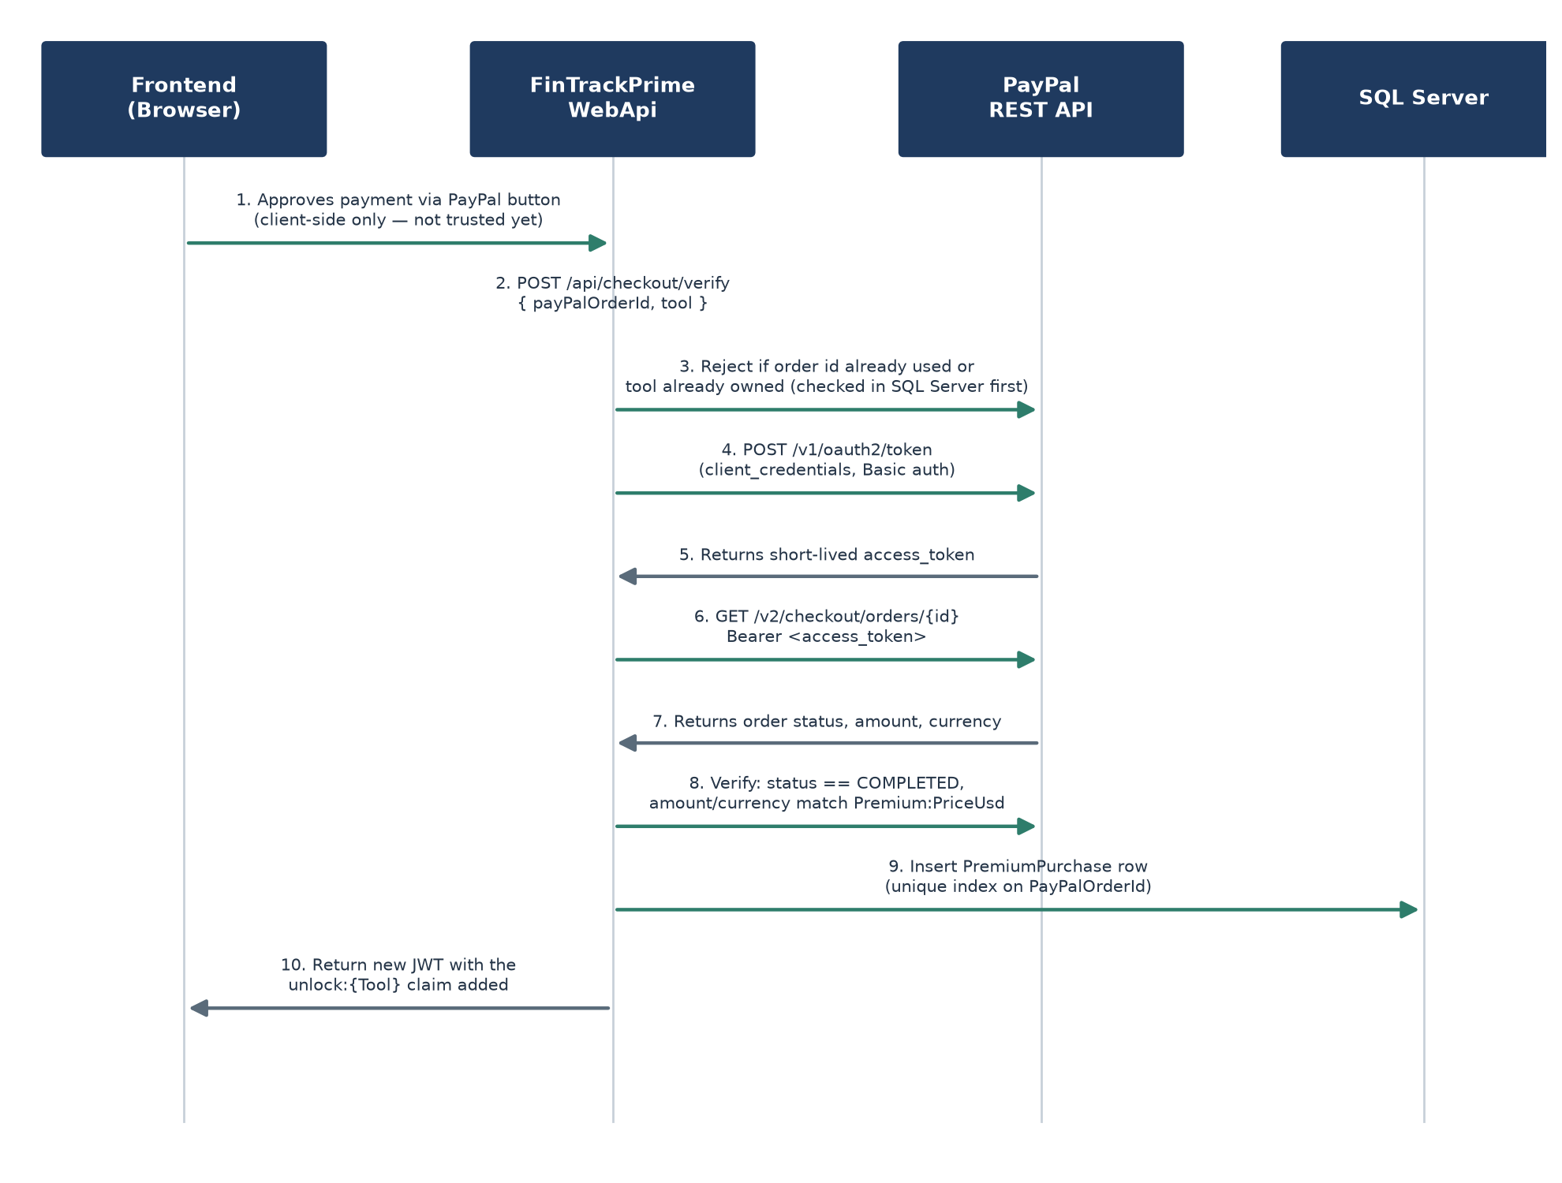
Figure 3 — PayPal order verification sequence.
Design note: the unique index on PayPalOrderId means the same completed PayPal order can never be replayed to unlock a tool twice, whether replayed on the same account or a different one.

6. Database Schema
All tables use a GUID primary key named Id. Every user-owned table has a foreign key back to Users with cascade delete, so removing a user removes everything that belongs to them.
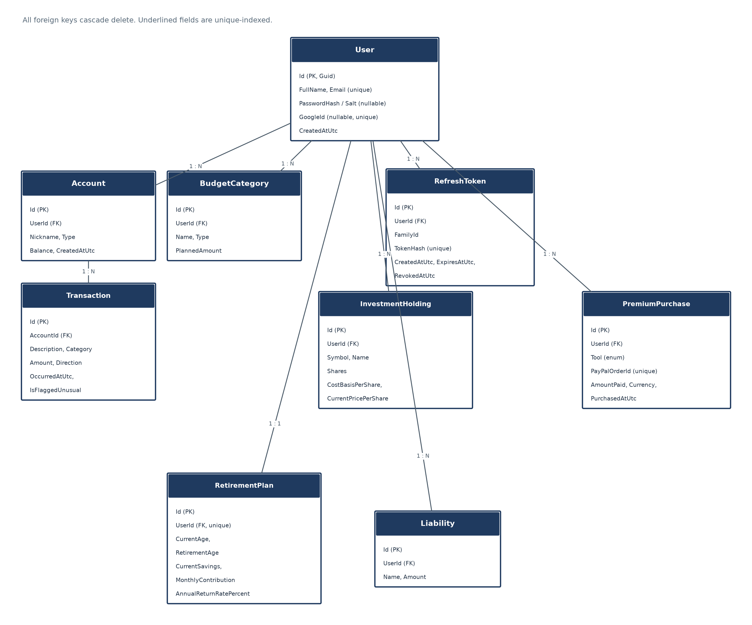
Figure 4 — Entity-relationship diagram.
Users
Field | Type | Notes
Id | GUID (PK)
FullName | nvarchar(120) | Required
Email | nvarchar(256) | Required, unique index
PasswordHash | nvarchar(256), nullable | Null for a Google-only account
PasswordSalt | nvarchar(256), nullable | Null for a Google-only account
GoogleId | nvarchar(64), nullable | Unique when present (filtered unique index — many rows may be NULL)
CreatedAtUtc | datetime2

Accounts
Field | Type | Notes
Id | GUID (PK)
UserId | GUID (FK → Users, cascade delete)
Nickname | nvarchar(max)
Type | int (enum: Checking, Savings)
Balance | decimal(18,2)
CreatedAtUtc | datetime2

Mock bank accounts for demonstration — not connected to any real banking rail.
Transactions
Field | Type | Notes
Id | GUID (PK)
AccountId | GUID (FK → Accounts, cascade delete)
Description | nvarchar(max)
Category | nvarchar(80) | Free-text; shared by Budget Planner and Cash Flow
Amount | decimal(18,2)
Direction | int (enum: Income, Expense)
OccurredAtUtc | datetime2
IsFlaggedUnusual | bit | Set by a standard-deviation outlier rule, not machine learning

BudgetCategories
Field | Type | Notes
Id | GUID (PK)
UserId | GUID (FK → Users, cascade delete)
Name | nvarchar(80) | Required
Type | int (enum: Income, Expense)
PlannedAmount | decimal(18,2)

New users are seeded with six starter categories (Salary, Housing, Utilities, Groceries, Transportation, Savings) at registration.
InvestmentHoldings
Field | Type | Notes
Id | GUID (PK)
UserId | GUID (FK → Users, cascade delete)
Symbol | nvarchar(12) | Required
Name | nvarchar(120) | Required
Shares | decimal(18,4)
CostBasisPerShare | decimal(18,4)
CurrentPricePerShare | decimal(18,4) | User-entered; no live market data feed

RetirementPlans
Field | Type | Notes
Id | GUID (PK)
UserId | GUID (FK → Users, cascade delete) | Unique — one plan per user (upserted, not a list)
CurrentAge | int
RetirementAge | int
CurrentSavings | decimal(18,2)
MonthlyContribution | decimal(18,2)
AnnualReturnRatePercent | decimal(5,2)

Liabilities
Field | Type | Notes
Id | GUID (PK)
UserId | GUID (FK → Users, cascade delete)
Name | nvarchar(120) | Required
Amount | decimal(18,2)

Manually entered; there is no automatic source for a user's debts.
PremiumPurchases
Field | Type | Notes
Id | GUID (PK)
UserId | GUID (FK → Users, cascade delete)
Tool | int (enum: LoanCalculator, InvestmentTracker, RetirementPlanner, FinancialStatement)
PayPalOrderId | nvarchar(64) | Required, unique index — prevents replaying one order twice
AmountPaid | decimal(18,2)
Currency | nvarchar(8)
PurchasedAtUtc | datetime2

RefreshTokens
Field | Type | Notes
Id | GUID (PK)
UserId | GUID (FK → Users, cascade delete)
FamilyId | GUID | Shared by every token in one rotation chain (one login session)
TokenHash | nvarchar(128) | Required, unique — SHA-256 hash of the raw token; the raw value is never stored
CreatedAtUtc | datetime2
ExpiresAtUtc | datetime2
RevokedAtUtc | datetime2, nullable

Relationship summary
Relationship | Cardinality
User → Account | 1 : N
Account → Transaction | 1 : N
User → BudgetCategory | 1 : N
User → InvestmentHolding | 1 : N
User → RetirementPlan | 1 : 1 (upserted)
User → Liability | 1 : N
User → PremiumPurchase | 1 : N (max 4 — one per tool)
User → RefreshToken | 1 : N

7. API Reference
All routes below are prefixed as shown. Authenticated routes require an Authorization: Bearer <JWT> header. Business-rule failures return { "message": "..." }; model-validation failures return the ASP.NET Core default ValidationProblemDetails shape.
Authentication — /api/auth (public)
Method & Route | Auth | Request body | Response
POST /api/auth/register | None | RegisterRequest  { fullName, email, password } | 200: AuthResponse + ftp_refresh cookie  409: { message } if email taken
POST /api/auth/login | None | LoginRequest  { email, password } | 200: AuthResponse + cookie  401: { message }
POST /api/auth/google | None | GoogleLoginRequest  { idToken } | 200: AuthResponse + cookie  401: { message }
POST /api/auth/refresh | None (ftp_refresh cookie) | (empty) | 200: AuthResponse + rotated cookie  401: { message }, cookie cleared
POST /api/auth/logout | None (ftp_refresh cookie) | (empty) | 204: No Content, cookie cleared

AuthResponse shape: { token, accessTokenExpiresAtUtc, fullName, email, unlockedTools: [tool names] }. The raw refresh token never appears in any response body — only in the ftp_refresh cookie.
Dashboard — /api/dashboard (Bearer)
Method & Route | Request body | Response
GET /api/dashboard | — | DashboardViewModel  { accounts: [{ id, nickname, type, balance, recentTransactions[≤25] }] }

Accounts — /api/accounts (Bearer)
Method & Route | Request body | Response
POST /api/accounts | CreateAccountRequest  { nickname, type, startingBalance } | 200: AccountViewModel
POST /api/accounts/{accountId}/transactions | CreateTransactionRequest  { description, category, amount, direction } | 200: TransactionViewModel  404: { message } if account not owned

Budget Planner — /api/budget-planner (Bearer)
Method & Route | Request body | Response
GET /api/budget-planner | — | BudgetPlannerViewModel  { categories[], totalPlannedIncome, totalPlannedExpenses, plannedNet }
POST /api/budget-planner | CreateBudgetCategoryRequest  { name, type } | 200: BudgetCategoryViewModel
PUT /api/budget-planner/{categoryId} | UpdateBudgetCategoryRequest  { name, plannedAmount } | 200: BudgetCategoryViewModel  404: { message } if not owned
DELETE /api/budget-planner/{categoryId} | — | 204: No Content  404: { message } if not owned

Cash Flow — /api/cash-flow (Bearer)
Method & Route | Request body | Response
GET /api/cash-flow | — | CashFlowViewModel  { totalIncome, totalExpenses, net, expenseByCategory[], monthlyTrend[] }

Checkout — /api/checkout (Bearer)
Method & Route | Request body | Response
GET /api/checkout/status | — | PremiumStatusViewModel  { unlockedTools: [{ tool, purchasedAtUtc }] }
POST /api/checkout/verify | VerifyPurchaseRequest  { payPalOrderId, tool } | 200: AuthResponse (fresh JWT)  400: { message } on any verification failure

Loan Calculator — /api/loan-calculator (Bearer + RequireLoanCalculator)
Method & Route | Request body | Response
POST /api/loan-calculator/calculate | LoanCalculationRequest  { principalAmount, annualInterestRatePercent, termMonths, extraMonthlyPayment } | 200: LoanCalculationResultViewModel  { requiredMonthlyPayment, payoffMonths, totalInterestPaid, totalPaid, schedule[] }

Stateless — nothing is persisted; each call is a standalone calculation.
Investment Tracker — /api/investment-tracker (Bearer + RequireInvestmentTracker)
Method & Route | Request body | Response
GET /api/investment-tracker | — | InvestmentPortfolioViewModel  { holdings[], totalCostBasis, totalCurrentValue, totalGainLoss }
POST /api/investment-tracker | CreateInvestmentHoldingRequest  { symbol, name, shares, costBasisPerShare, currentPricePerShare } | 200: InvestmentHoldingViewModel
PUT /api/investment-tracker/{holdingId} | UpdateInvestmentHoldingRequest  { shares, costBasisPerShare, currentPricePerShare } | 200: InvestmentHoldingViewModel  404: { message } if not owned
DELETE /api/investment-tracker/{holdingId} | — | 204: No Content  404: { message } if not owned

Retirement Planner — /api/retirement-planner (Bearer + RequireRetirementPlanner)
Method & Route | Request body | Response
GET /api/retirement-planner | — | RetirementPlanViewModel  (a reasonable starter scenario if the user hasn't saved one yet — nothing is written until they do)
PUT /api/retirement-planner | RetirementPlanInputRequest  { currentAge, retirementAge, currentSavings, monthlyContribution, annualReturnRatePercent } | 200: RetirementPlanViewModel  400: { message } if retirementAge ≤ currentAge

Financial Statement — /api/financial-statement (Bearer + RequireFinancialStatement)
Method & Route | Request body | Response
GET /api/financial-statement | — | FinancialStatementViewModel  { assets[], totalAssets, liabilities[], totalLiabilities, netWorth, generatedAtUtc }
POST /api/financial-statement/liabilities | CreateLiabilityRequest  { name, amount } | 200: LiabilityViewModel
DELETE /api/financial-statement/liabilities/{liabilityId} | — | 204: No Content  404: { message } if not owned

Assets combine every account balance and every investment holding's current value; there is no separate ledger — it is a computed view over data the other tools already collected.

8. NuGet Package Reference
Only packages actually referenced in each project's .csproj file are listed.
FinTrackPrime.Models
Package | Version | Purpose
Microsoft.EntityFrameworkCore | 10.0.10 | Core EF Core ORM — DbContext, DbSet, change tracking, LINQ-to-SQL translation.
Microsoft.EntityFrameworkCore.SqlServer | 10.0.10 | EF Core database provider for SQL Server.

FinTrackPrime.Business
Package | Version | Purpose
Microsoft.EntityFrameworkCore | 10.0.10 | Services in this layer query FinTrackDbContext directly.
System.IdentityModel.Tokens.Jwt | 8.22.0 | Builds and signs the JWT access token (JwtTokenGenerator).
Microsoft.Extensions.Configuration.Abstractions | 10.0.10 | IConfiguration, so services can read appsettings.json sections without depending on ASP.NET Core.
Microsoft.Extensions.Configuration.Binder | 10.0.10 | Strongly-typed configuration binding / GetValue<T>() (e.g., RefreshToken:ExpiryDays).
Google.Apis.Auth | 1.73.0 | Server-side validation of Google Sign-In ID tokens (GoogleJsonWebSignature).

FinTrackPrime.WebApi
Package | Version | Purpose
Microsoft.AspNetCore.Authentication.JwtBearer | 10.0.10 | Validates incoming JWT bearer tokens on every request (issuer, audience, lifetime, signature).
Microsoft.EntityFrameworkCore.Design | 10.0.10 (design-time only) | Powers dotnet ef migrations tooling; not shipped in the running app.
Swashbuckle.AspNetCore | 10.2.3 | Generates the OpenAPI/Swagger document and the interactive Swagger UI.

No PayPal-specific NuGet package is used. PayPalClient calls PayPal's REST API directly over a typed HttpClient, so the integration is plain HTTP + JSON rather than a vendor SDK.
9. Configuration Reference
Configuration lives in appsettings.json. Real credential values are redacted below and shown as placeholders — see the project's own configuration file for actual sandbox/production values.
Section : Key | Purpose
ConnectionStrings:Default | SQL Server connection string. Redacted here — <server, database, credentials>.
Jwt:Key | Symmetric signing key for access tokens. Must be a long random secret in any real deployment.
Jwt:Issuer / Jwt:Audience | JWT issuer/audience values validated on every request.
Jwt:AccessTokenMinutes | Access token lifetime. Default: 15 minutes.
RefreshToken:ExpiryDays | Refresh token lifetime. Default: 30 days.
Google:ClientId | OAuth audience checked when validating a Google ID token. Redacted here.
Cors:AllowedOrigins | Array of allowed frontend origins for the CORS policy. Default: http://localhost:5173.
PayPal:ClientId / PayPal:ClientSecret | Sandbox app credentials used for the OAuth2 client-credentials grant. Redacted here.
PayPal:ApiBaseUrl | PayPal REST API host. Configured to PayPal's sandbox host; swapped to the live host for production.
Premium:PriceUsd / Premium:Currency | Expected price and currency checked against every verified PayPal order. Same flat price for all four tools.

